FREEDOM HIGH SCHOOL
2500 Taft-Vineland Road
Orlando, FL 32837
(407) 816-5600

Algebra 1
Summer Assignment 2020-2021

Congratulations! You have made it to high school, and you are enrolled in Algebra 1 for 2020-21 school year. Algebra 1 Course counts as a mathematics credit at Freedom High School, and will prepare you for the next course in your math progression. You will also be required to take the Florida State Assessment (FSA) at the end of this course.

Remember, by enrolling in this course, you are not only satisfying a graduation requirement you are also making a commitment to show excellence in your daily work. A successful student displays the following characteristics:

- Daily review of new material taught in class
- Diligent completion of homework and class assignments
- Being accountable for your work
- Understanding concepts vs. cramming for tests
- Organizing notes and materials
- Asking questions in class and out of class if needed
- Participation in group work
- Respect everyone in the classroom

Because Algebra 1 builds on prior knowledge, the problems in this packet are designed to help you review previous mathematics skills that are important in order to succeed in Algebra 1. You must show ALL work neatly. You may use your notes from previous mathematics courses to help you as well. You can also use youtube “how to” videos, Khan academy and any other resources you feel will assist you. However, the work must be done without the help from another person.

It is preferred you complete these skill sheets during the week of July 30, 2020, so that when we start the year, you will remember the skills necessary to become successful.

Struggling to remember?? Great resources are:
Freedom High Algebra 1 Summer Assignment assistance
https://www.khanacademy.org/math/algebra
https://www.mathsisfun.com/algebra/index.html

Have questions? Email Me!! 115935@ocps.net

DUE Friday, August 14th 2020

BRING THIS COMPLETED PACKET WITH YOU ON YOUR FIRST DAY OF SCHOOL. You may use your own paper or print it out. You MUST show work.

Summer Review/ Algebra I Packet Name______________________

No calculators may be used on ANY part of the packet, show work.
No work, No credit. Put a BOX around each answer
SECTION 1

Add/Subtract integers: Don’t forget to box your answer. Evaluate: Show your work.

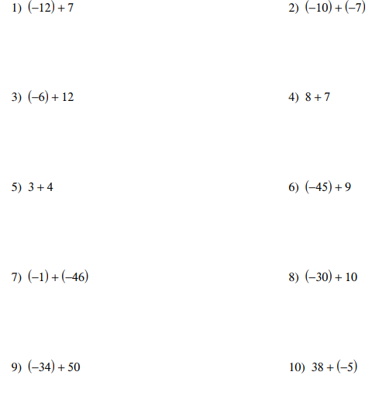

SECTION 2
Adding/Subtracting Fractions Box your answer (hint: must have same denominator)

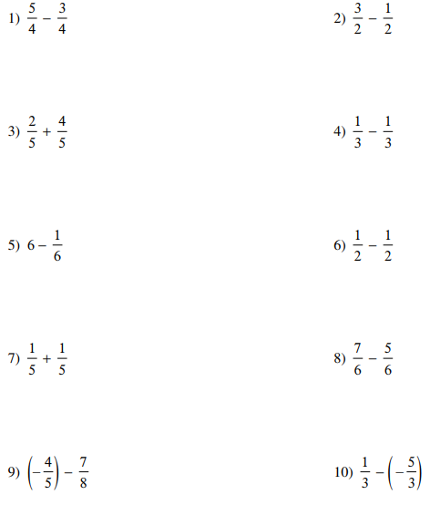

SECTION 3

Multiplying/Dividing Fractions Box your answer. Find the product:
Hint: multiply straight across. Division: keep change flip

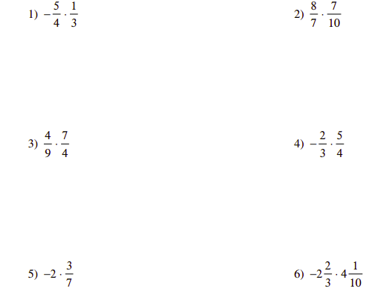

Find each quotient:
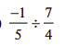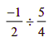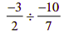
‘

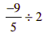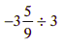

SECTION 4

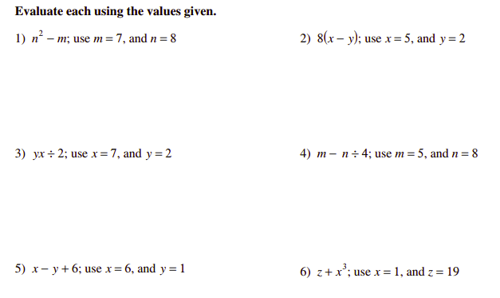

SECTION 5

Order of Operations: PEMDAS. Please Excuse My Dear Aunt Sally
P arenthesis simplify what is inside the parentheses

E xponents

M ultiply and
D ivide in order from left to right

A dd and
S ubtract in order from left to right

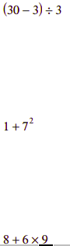

SECTION 6
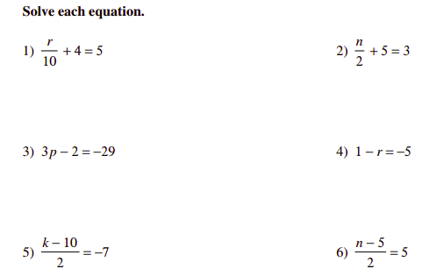

SECTION 7

No calculators may be used, show work. No work, No credit

1.Find the sum of -20 and 5. | 2. Find the difference of -20 and 5. | 3. Find the product of -20 and 5.
4. Find the quotient of -20 and 5. | 5. Solve for x: 20 + x = 70. | 6. Solve for x: x - 30 = 64.
7. Solve for x: $\frac{x}{20}$= 2. | 8. Solve for x: $\frac{20}{x}$ = 2. | 9. Solve for x: 25x = 75.
10. Solve for d: C = $π$d | 11. Combine like terms:  2$x^{2}$+ 7xy - 3$x^{2}+ 4y$ | 12. Evaluate:  $$2\left(10-4\right)+ 5^{3} ^{}$$

Congratulations!!

You have completed the Summer Packet. Below is a list of items you will need for Algebra 1. Please bring these items and your completed packet on your first day of school as we will begin working.

Pencils and erasers
3-4 pkgs - loose leaf paper
1 pkg. graph paper
Highlighter
1 3” ring binder with pockets OR 1 3-pronged folder with pockets
Hand sanitizer
kleenex/tissue
Dry erase marker(s)

